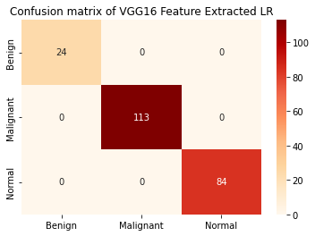

**Figure:** Confusion Matrix of Transfer Learning Feature Extracted Logistic Regression.

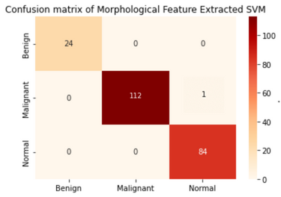

**Figure:** Confusion Matrix of Morphological Feature Extracted Support Vector Machine.